Page d’acceuil :

- Changer les deux images de fond avec la même image mais en meilleure qualité.
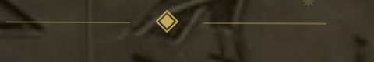
- enlever ça :

- Le nom “Neb Tawy” n’est pas aligné sur l’écran d’acceuil : je veux qu’il soit bien au centre
- mettre “Private Tarot Readings & Spiritual Guidance” plutôt que “palm readings and spiritual guidance”

Quand pn scroll sur la deuxième partie :

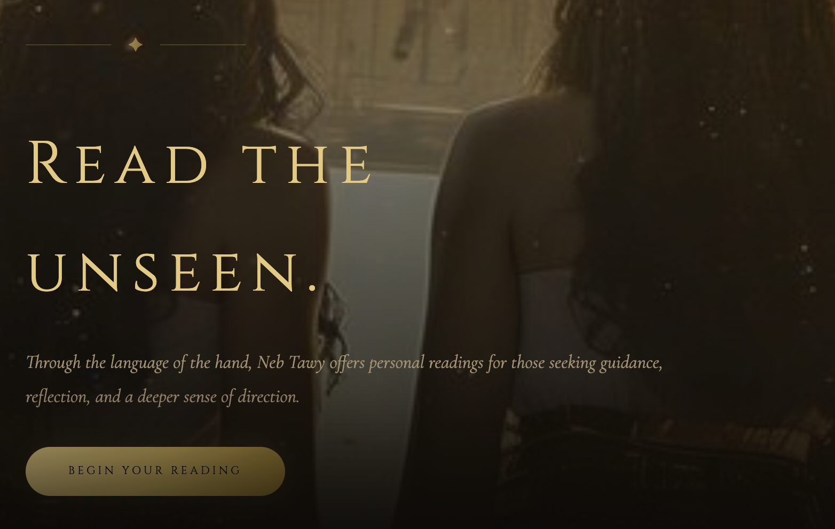

- Retirer le trait et la petit etoile au dessus
- A la place de “read the unseen” => Guidance for the Path Ahead et aligner sur la longueur (ne pas superposer les mot” et centrer comme le nom neb tawy .
- Remplacer le texte d’en dessous avec : Thoughtful tarot readings for moments of uncertainty, growth, and transformation.

- remplacer “begin your reading” par “book your private reading”

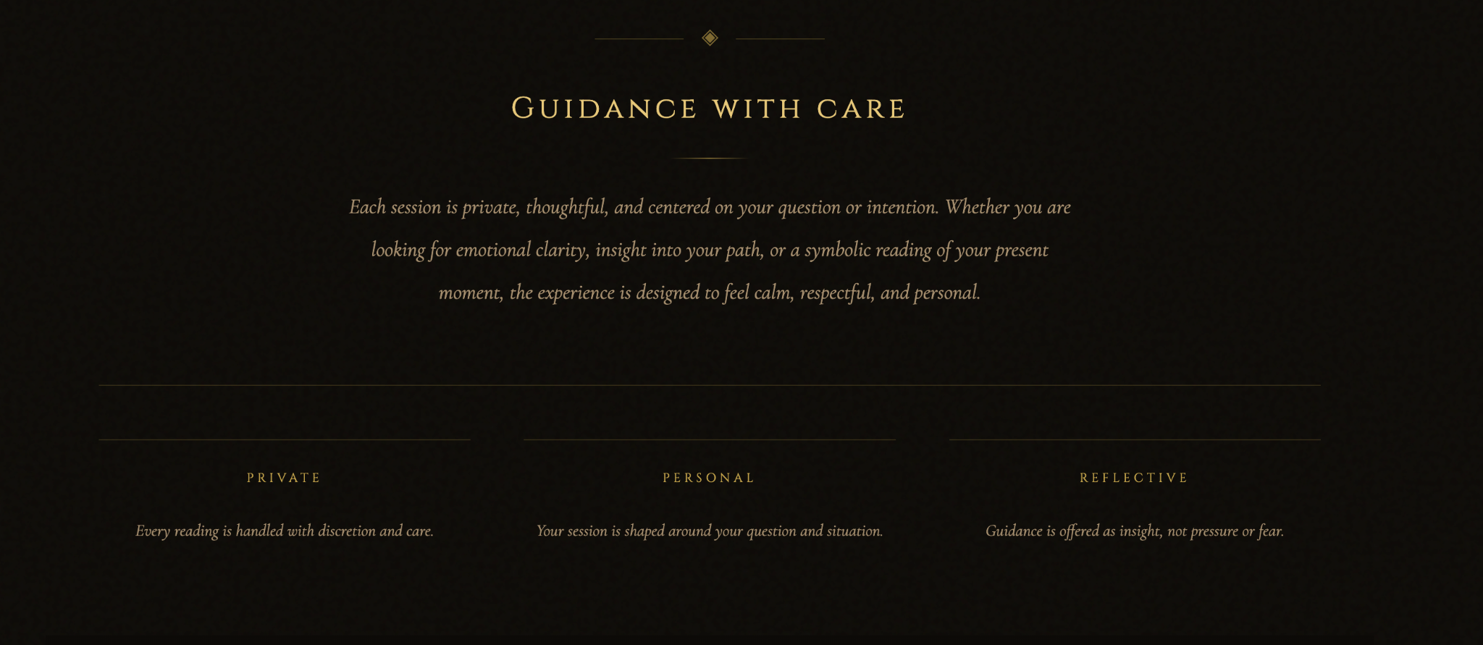

remplacer le texte par : With Neb Tawy, tarot readings are a space for reflection, insight, and meaningful conversation. Each reading is designed to help you explore your questions, recognize patterns, and move forward with greater clarity and intention.

retirer tout ça

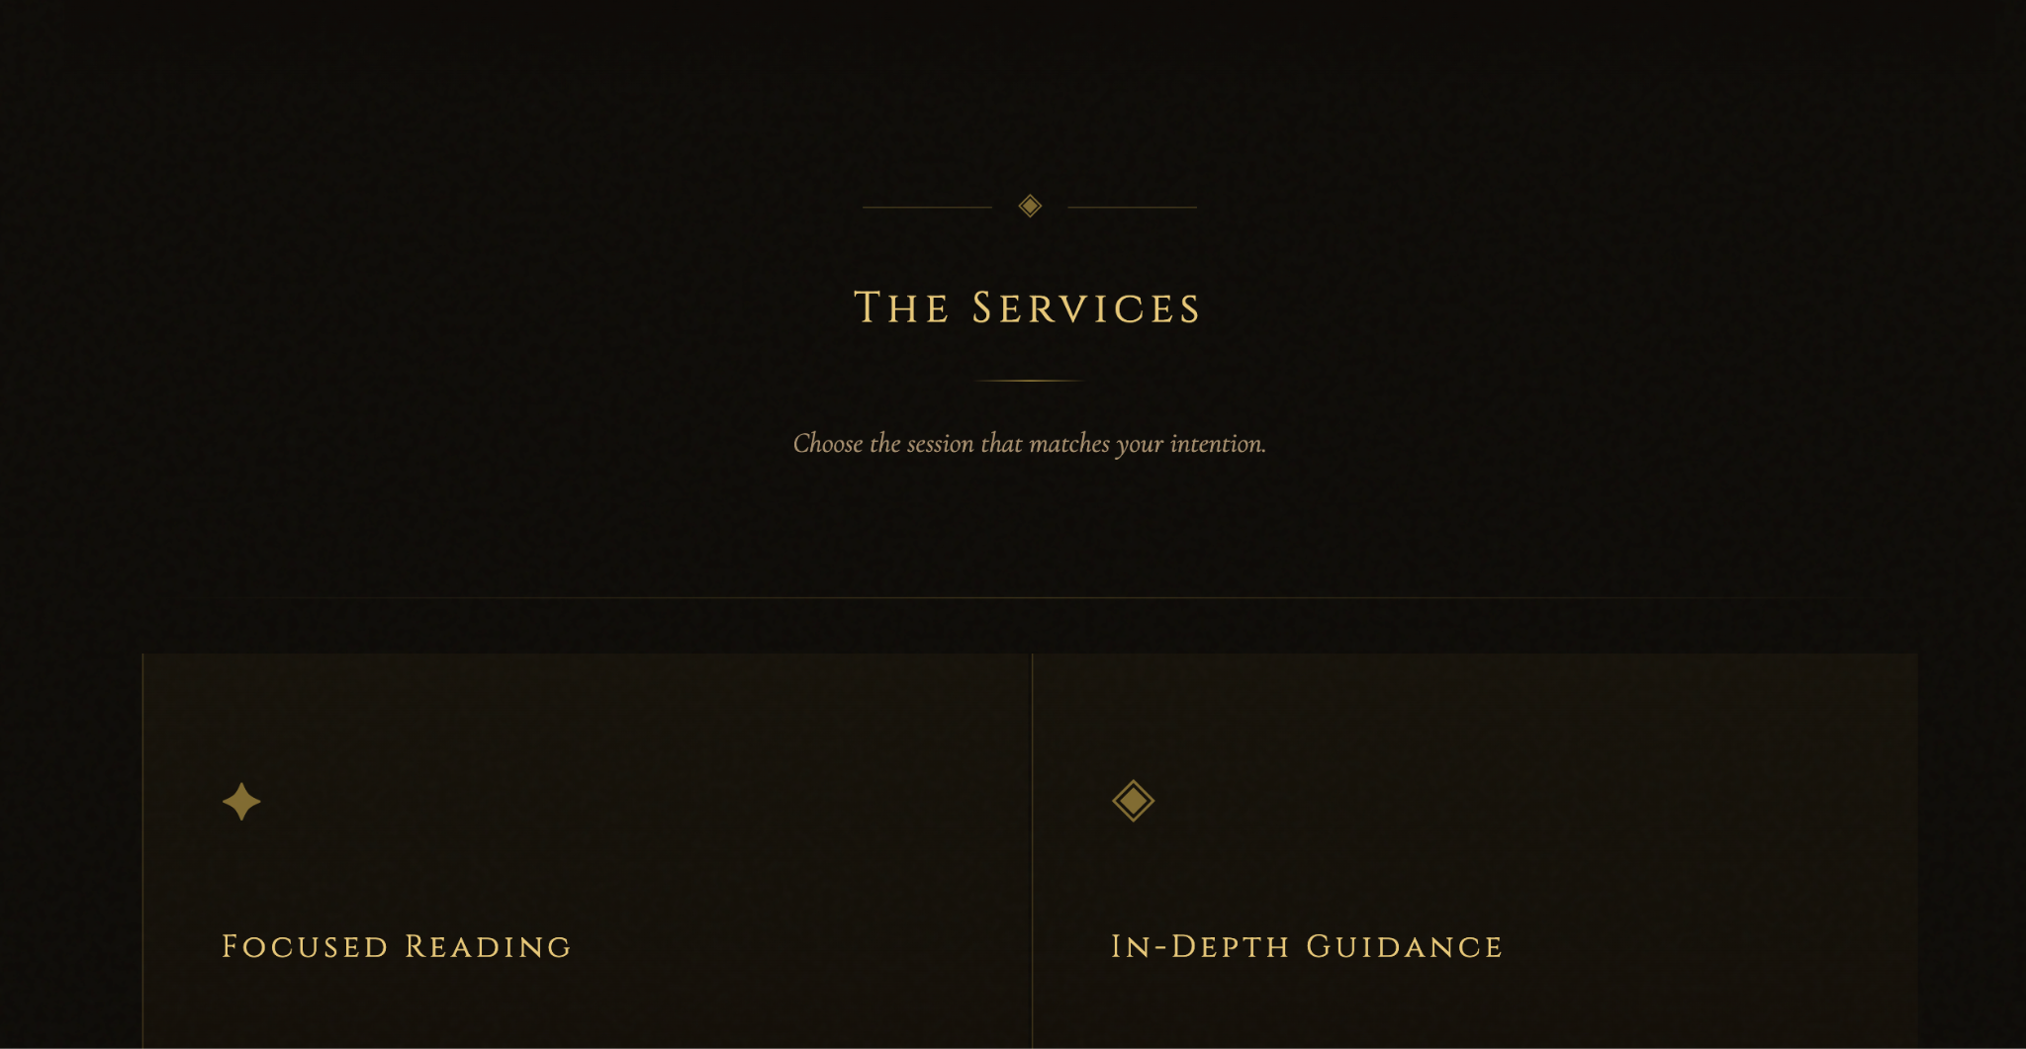

- change : Choose the session that matches your intention. par : “Each guidance is prepared individually, with care and intention.”


- retire les petites étoiles qu’il ya a chaque fois au dessus des services proposées comme ici :

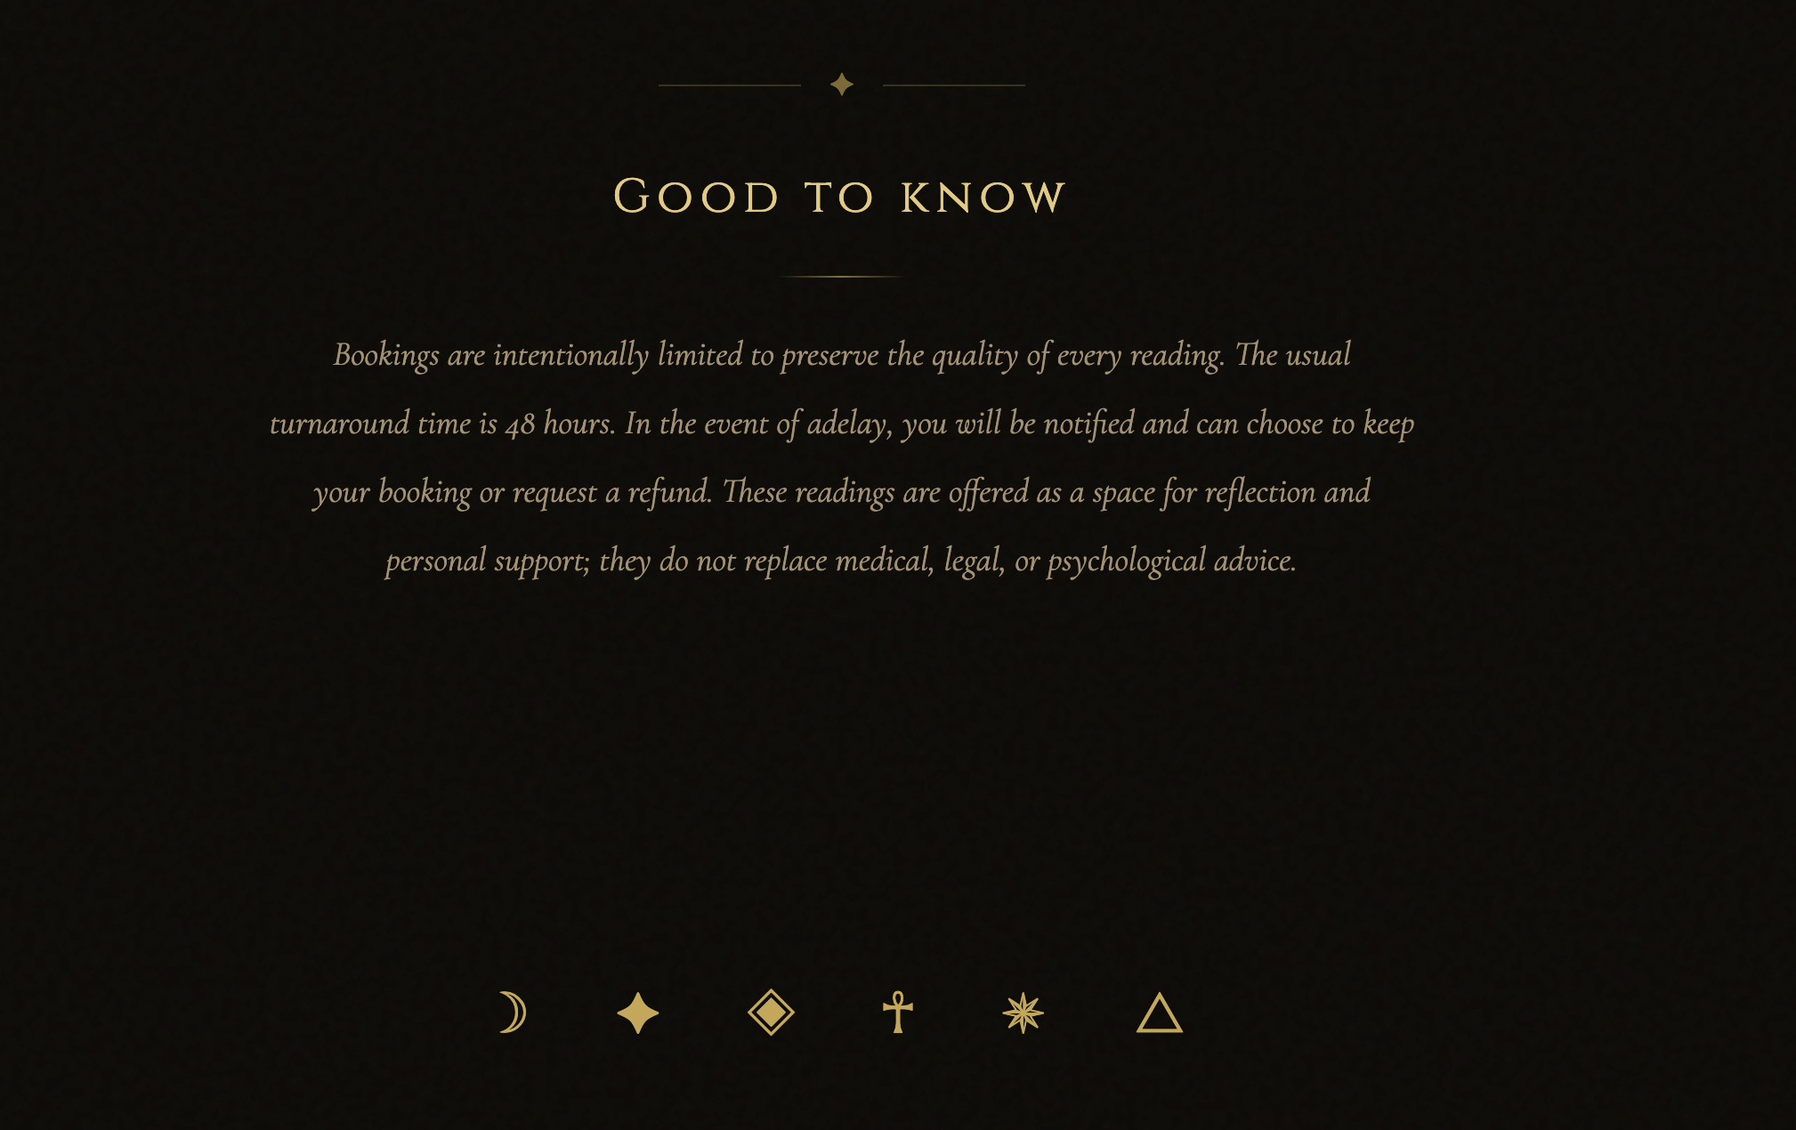

- remplace “good to know” par “before with begin”
et le texte contient une erreur : mettre un espace entre a et delay pas “adelay”


- retire tout ça :

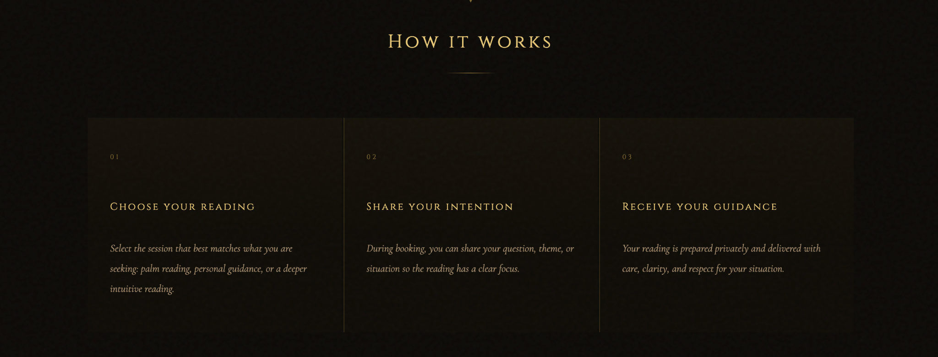

- suivre cette ordre : 01 — Set Your Intention
Begin with a clear question or the area of your life you would like to explore. A brief context is welcome if you feel it is necessary, but it is never required. Every guidance begins with your intention.

02 — Choose Your Guidance
Select the guidance that best suits your needs. Whether you are seeking clarity on a single question or a more in-depth exploration, each reading is prepared with the same care and attention.

03 — Receive Your Guidance
Your reading is prepared privately and delivered within 48 hours. Every guidance is created individually with care, intuition and respect for your personal journey.
page booking :
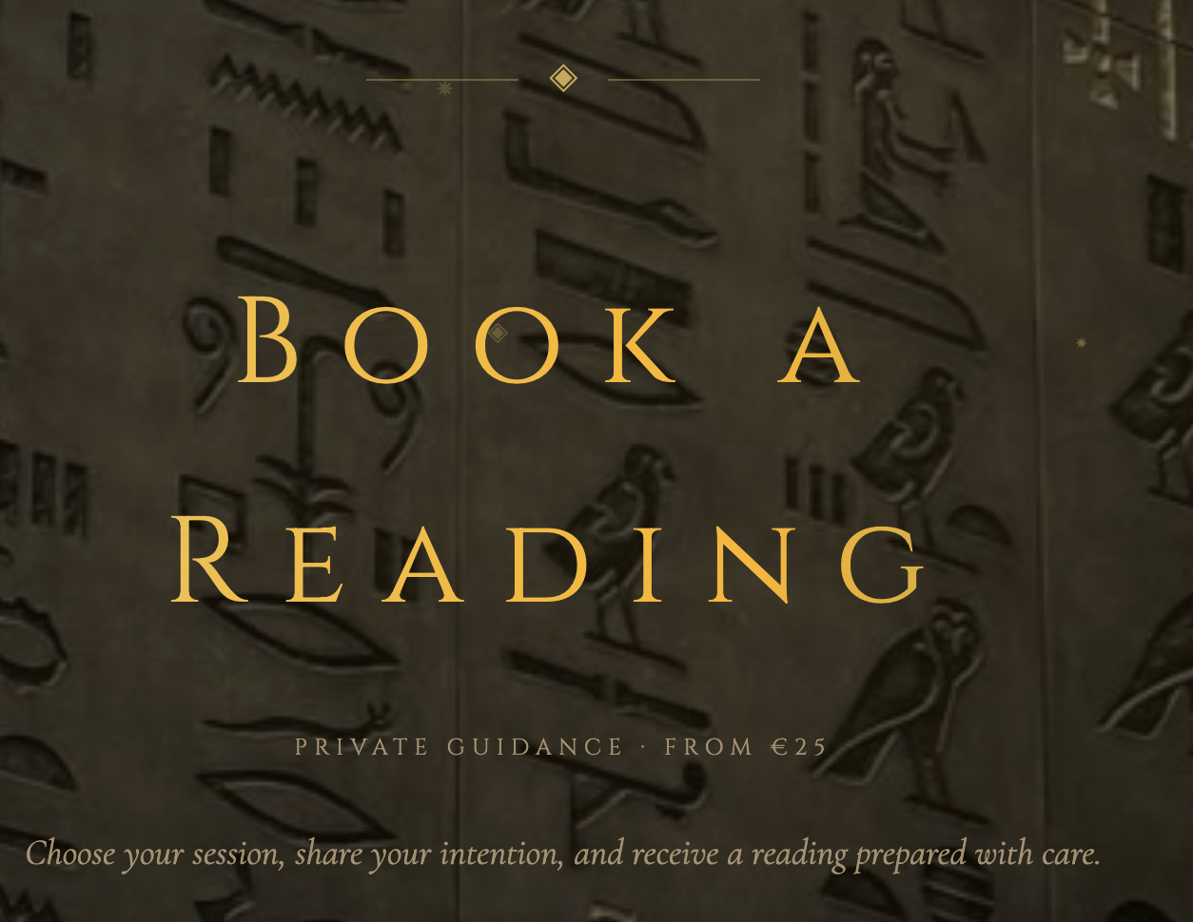

mieux centrer le titre, mettre “book a private readings” aligner sans que les mots se superposent

changer la petite phrase en cursive par “ set your intentions, choose a session and received a reading prepared with care”

retire ça :

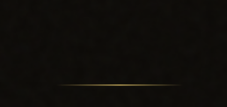
retire aussi ce petit trait qu’on voit partout sur le reste de la page de booking

Page “about”

changer l’image de fond en image de meilleurs qualité. 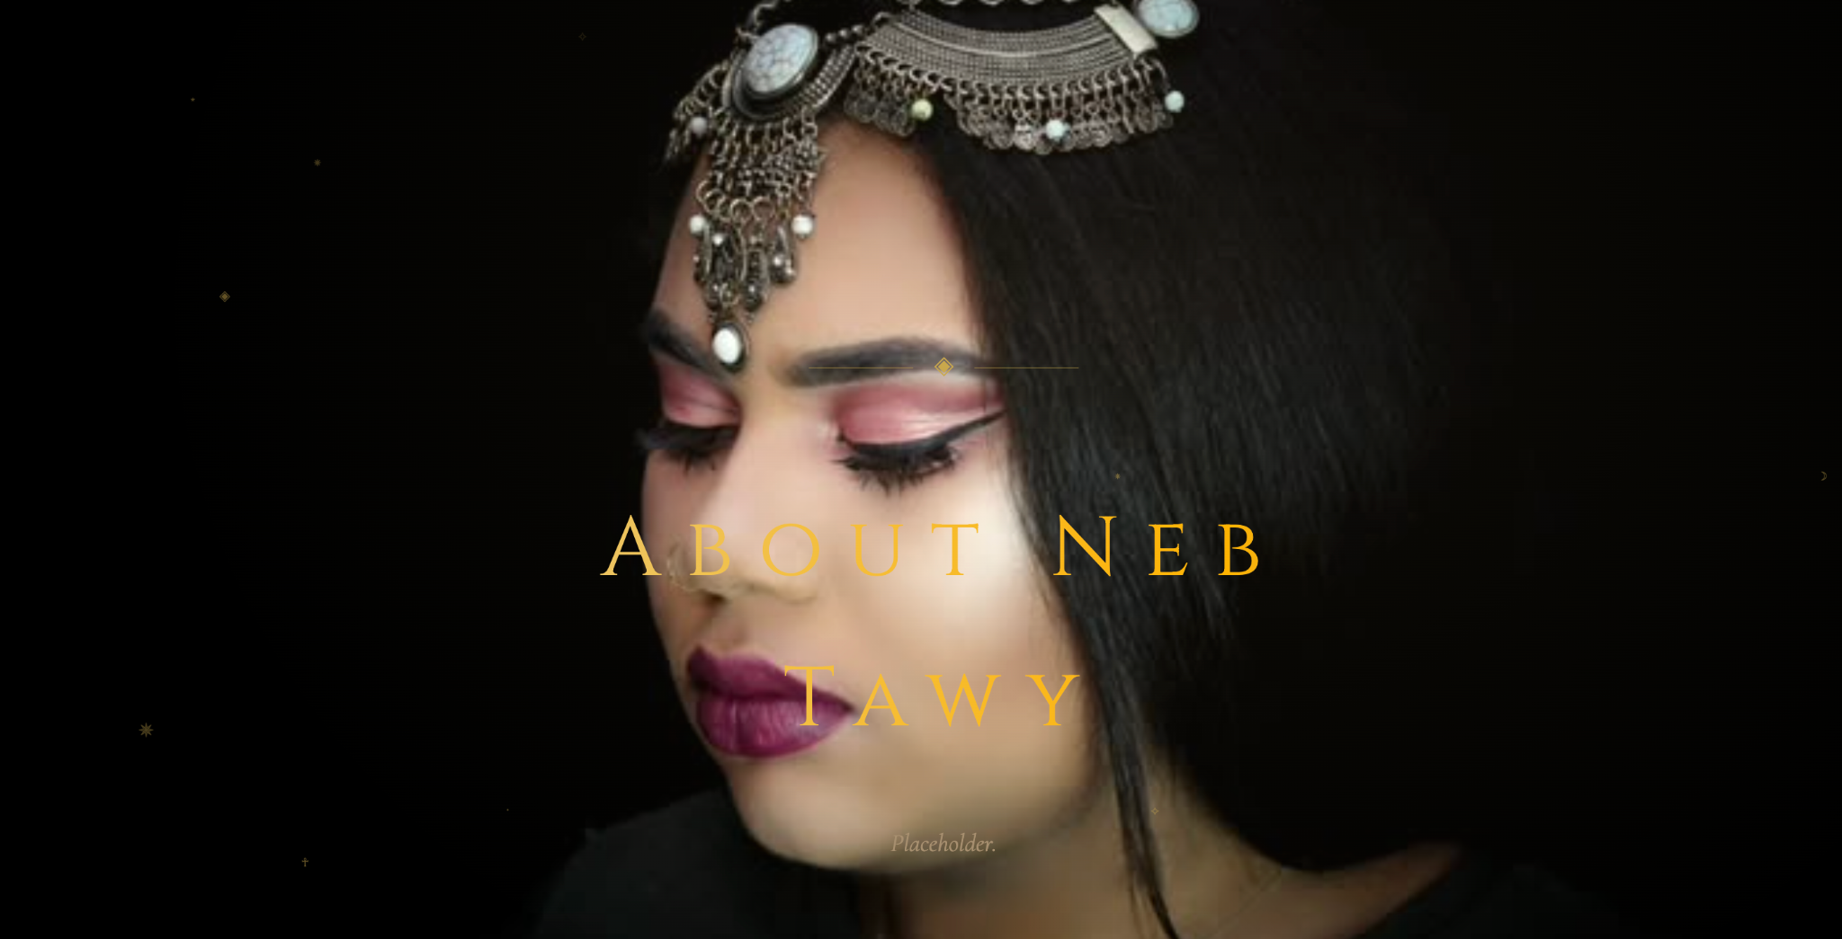

decaler ma photo sur la droite et faire en sorte que ma tête ne soit pas aussi agrandi, en gros, réduit la photo et met la sur le coté et à gauche met “ ABOUT NEB TAWY” avec NEB TAWY en dessous de ABOUT.

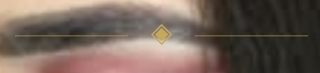
enlève ce truc stp

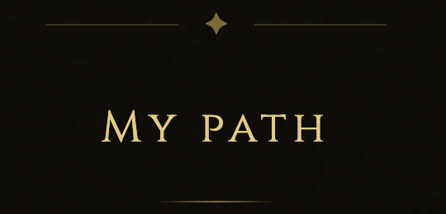

remplacer my path par : My philosophy

Texte à rajouter en dessous :
Ever since I was a kid and for many years, spirituality was something I explored through religion. In 2022, my path shifted in a way I never expected. What began as a personal search for meaning became a profound journey inward, one that transformed the way I understand intuition, consciousness and the unseen world.
Although I had experienced intuitive moments throughout my life, it was during this period that I became fully aware of my own intuitive abilities. Rather than learning tarot through traditional study, I discovered that my relationship with the cards developed naturally through practice, meditation and trust in my own inner guidance.
Today, tarot has become one of the ways I help others reconnect with themselves. I do not see tarot as a tool that predicts a fixed future.
To me, every reading is an invitation to better understand the present: to uncover hidden emotional patterns, recognize unconscious dynamics and explore the possibilities that exist within the current moment.
Our choices, our beliefs and our awareness all shape the paths available to us. Rather than telling you who you are or what must happen, the cards encourage reflection, clarity and empowerment.
This is why I ask for as little information as possible before each reading. A simple question is often enough. Allowing the cards to speak before the story helps me approach each reading with openness, intuition and as little personal bias as possible. Alongside tarot, I also work with dowsing rods when deeper energetic clarification is needed. They are another intuitive tool that occasionally complements my readings.
My personal spiritual path is deeply connected to what I describe as the energy of the Dragon Rider. Within my own practice, dragons represent wisdom, transformation, courage and protection. I experience them as spiritual allies who accompany my intuitive work and help me remain connected to my higher self and inner guidance. While every person's spiritual journey is unique, this symbolic relationship forms an important part of mine.
Above all, my intention is never simply to provide answers. It is to help you understand yourself more deeply.
My hope is that every reading leaves you with more than guidance, it leaves you feeling clearer, more empowered and more connected to your own path.

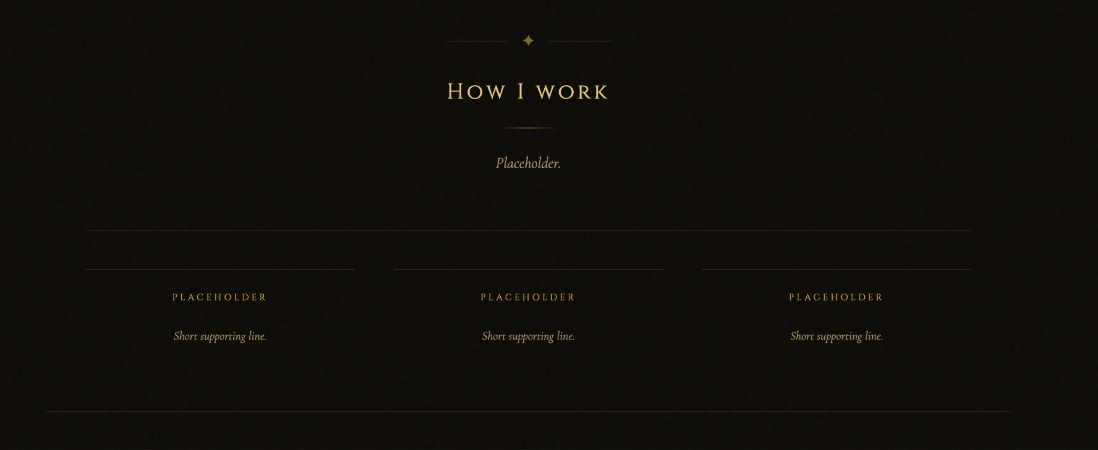
retire toutes ces sections :

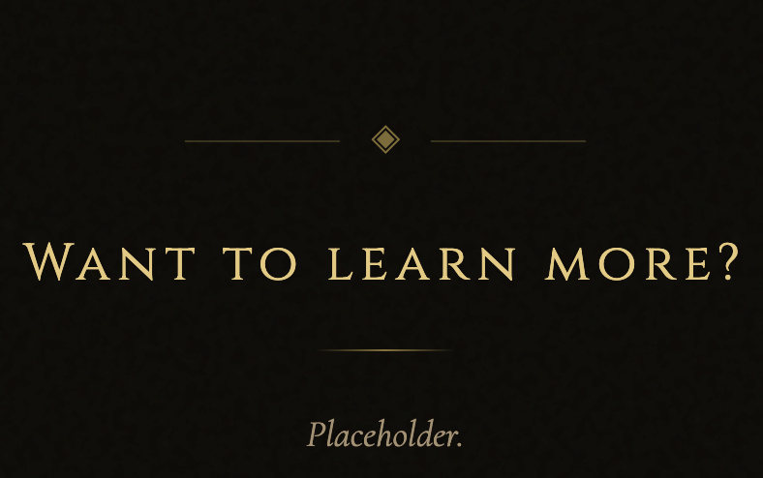

tu peux juste laisser “book a reading”

